**Survival analysis**

* This is the Kaplan-Meier plot produced when looking at time from diabetes diagnosis to earliest severe retinopathy code
  + Obviously it looks utterly ridiculous because there were very few events

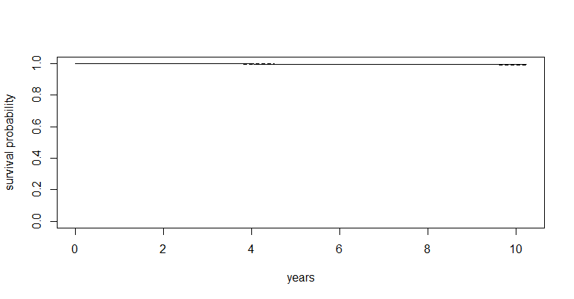

**Cox Proportional Hazard Model**

* Exponentiated coefficients (hazard ratios)
  + Age at diagnosis
    - For each additional year, there is a 2.14% decrease in hazard
  + Gender
    - Not significant
  + Ethnicity
    - Not significant
  + IMD
    - For every decile increase, there is a 3.94% increase in hazard
  + HbA1C
    - For every mmol/mol increase, there was a 2.78% increase in hazard
  + BMI
    - For every kg/m2 increase, there was a 5.23% decrease in hazard
  + eGFR
    - For every ml/min/1.73m2 increase, there was 0.17% increase in hazard
  + HDL
    - For every mmol/L increase, there was a 45.03% increase in hazard
  + ALT
    - For every U/L increase, there was a 1.39% decrease in hazard
  + SBP
    - For every mmHg increase, there was a 3.19% increase in hazard

* Plot of hazard ratios and 95% CIs:

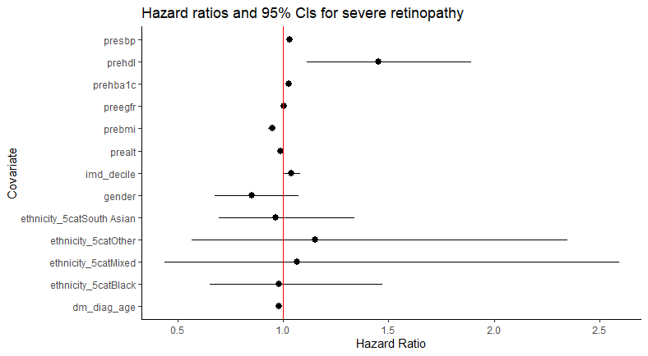

**Stepwise model process table**

* Step 1:

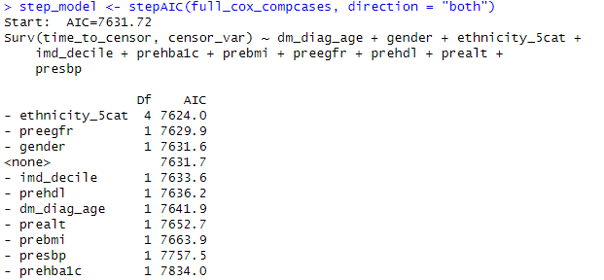

* Step 2
  + Has taken out ethnicity

* Step 3
  + Has taken out baseline eGFR

* Step 4
  + Has taken out gender

* Summary of the best cox model

